Lesson 7: How much does doubling the speed or doubling the mass affect the kinetic energy of an object and the resulting damage that it can do in a collision?

Previous Lesson | We looked back at questions from our Driving Question Board and answered questions we had made progress on during Lesson Set 1. We took an assessment to apply our science ideas to a new context and determined that we needed to figure out what causes more damage and energy transfer in a collision--increases in mass or increases in speed.
This Lesson  Investigation  2 days   | 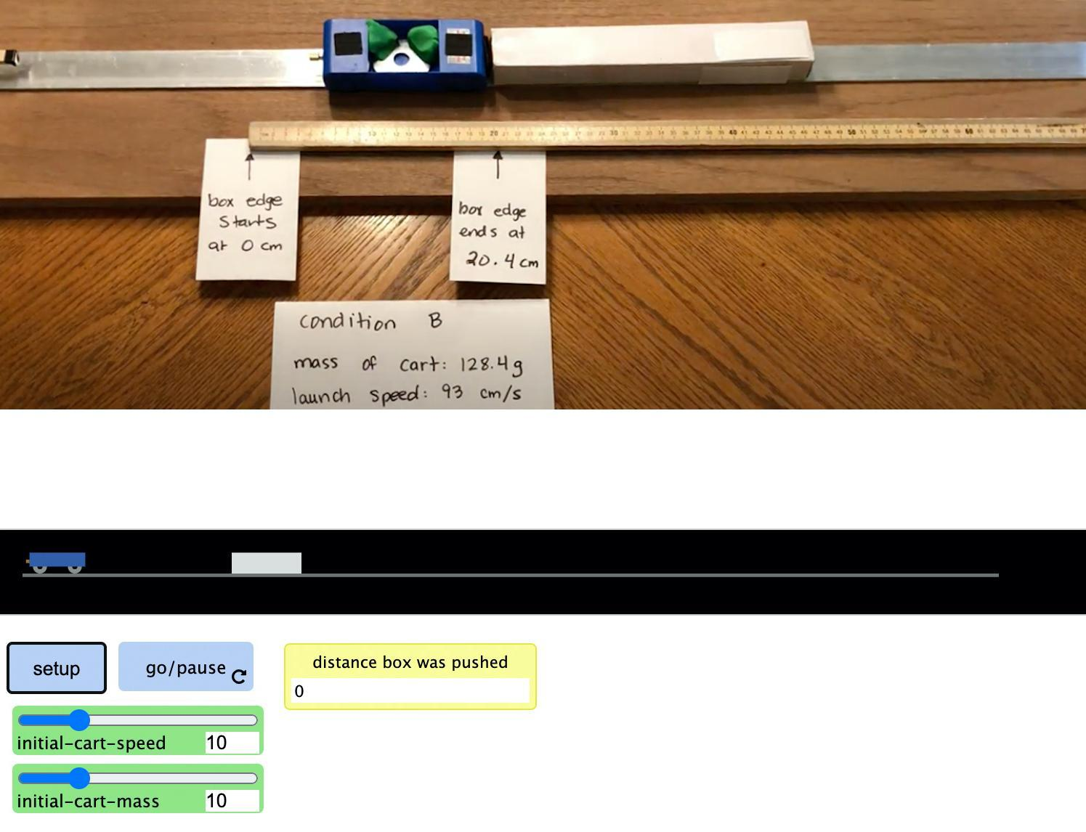 | We carry out an investigation to determine how doubling the speed of an object vs. doubling its mass affects the amount of damage it does in a collision. We analyze data to determine how to quantify the relative change in the kinetic energy of an object. We use a computer simulation to collect additional data on changes in the mass and speed of a moving object and the amount of kinetic energy. We develop mathematical models of these relationships and use them to predict and explain how this could affect the amount of damage in a collision.
Next Lesson | We will develop a model to show where energy is transferred between the spring, cart, and box and how contact forces cause this energy transfer. We will use this to start brainstorming other places where contact forces may be causing energy transfer in the system.

BUILDING TOWARD NGSS  MS-PS2-1, MS-PS2-2, MS-PS3-1, MS-ETS1-2, MS-ETS1-3, MS-LS1-8   | What students will do  7.A Construct, analyze, and interpret graphical displays of data collected from a computer simulation to identify patterns in the data, including a linear relationship between the mass of a moving object and its kinetic energy and its kinetic energy and a nonlinear relationship between the speed of a moving object and its kinetic energy.  7.B Construct an explanation based on quantitative relationships (scale) for whether decreasing the mass of a moving object or decreasing its speed would have a bigger effect on the peak forces produced in a collision between it and a stationary object and use these ideas to further explain why this would cause damage in some collisions but not others (effect).  What students will figure out  - In an investigation with multiple independent variables it is important to keep track of which variables are remaining constant and which are changing.  - The more kinetic energy an object has the more damage it can do in a collision.  - The more kinetic energy an object has the more you have to push against the direction of its motion to get it to stop.  - The kinetic energy of an object is directly proportional to its mass; the KE of an object is proportional to the square of its speed.

Lesson 7 • Learning Plan Snapshot
Part | Duration |  | Summary | Slide | Materials
1 | 5 min |  | NAVIGATION  Recall what was figured out in the prior lessons. | A | chart paper, markers
2 | 12 min |  | PLANNING OUR INVESTIGATION  Plan an investigation to collect data about the effects on kinetic energy of a colliding object when the mass or the speed of the object is doubled. | B | Changes in Kinetic Energy: Investigations #1 & 2, chart paper with investigation question, markers
3 | 14 min |  | CARRY OUT AN INVESTIGATION ON DAMAGE FROM DOUBLING MASS VS. SPEED  Carry out an investigation to collect data about how doubling the mass and doubling the speed of an object affects the kinetic energy and the damage done in a collision. | C | Procedure for Investigation 1, Changes in Kinetic Energy: Investigations #1 & 2, Damage from Doubling Mass vs. Speed Lab
4 | 4 min |  | ARGUE FROM EVIDENCE FOR WHICH FACTOR AFFECTS KINETIC ENERGY MORE  Argue from evidence about how the changes in the mass or the speed of an object affect the amount of kinetic energy that is transferred.
5 | 12 min |  | ANALYZING DATA FROM A QUANTITATIVE MEASURE OF ENERGY TRANSFER  Analyze videos of a spring-launched cart colliding with and pushing a box different distances depending on the mass and speed of the cart when launched. | D-G | Changes in Kinetic Energy: Investigations #1 & 2, computer, projector, https://youtu.be/ygLbCFuqYFo, https://youtu.be/XgczgVAiCYk, https://youtu.be/3Rzt0wNQAT0

End of day 1
6 | 5 min |  | NAVIGATION  Share patterns and predictions related to scaling up the mass or speed of a moving object and the relative increase in its kinetic energy. | H | Changes in Kinetic Energy: Investigations #1 & 2
7 | 5 min |  | PLANNING FOR USING A COMPUTATIONAL SIMULATION  Orient to a computational simulation for collecting additional data on the relationship between changes in mass or speed and the kinetic energy of an object. | I | 2 copies of Graphing Kinetic Energy Relationships, optional: 1 copy each of Alternate: Graphing Mass vs. Kinetic Energy and Alternate: Graphing Speed vs. Kinetic Energy, computer, projector, https://www.openscied.org/collision2-simulation/
8 | 15 min |  | COLLECTING AND GRAPHING DATA FROM A COMPUTATIONAL SIMULATION  Use a computational simulation to collect additional data on the relationship between changes in mass and speed and the kinetic energy of an object. Graph the data collected. | J | 2 copies of Graphing Kinetic Energy Relationships, optional: 1 copy each of Alternate: Graphing Mass vs. Kinetic Energy and Alternate: Graphing Speed vs. Kinetic Energy, computer, https://www.openscied.org/collision2-simulation/
9 | 10 min |  | ANALYZE AND INTERPRET RESULTS OF OUR INVESTIGATION  Discuss the relationships in the graphs and tables for changes in mass and speed and the kinetic energy of an object. | K | calculator, 2 copies of Graphing Kinetic Energy Relationships, optional: 1 copy each of Alternate: Graphing Mass vs. Kinetic Energy and Alternate: Graphing Speed vs. Kinetic Energy, chart paper, markers
10 | 5 min |  | INDIVIDUAL EXPLANATIONS  Construct an explanation for whether decreasing the mass of a moving object or decreasing its speed would have a bigger effect on the peak forces produced in a collision and use these ideas to further explain why this would cause damage in some collisions but not others (effect). | L | 2 copies of Graphing Kinetic Energy Relationships, optional: 1 copy each of Alternate: Graphing Mass vs. Kinetic Energy and Alternate: Graphing Speed vs. Kinetic Energy, Looking back: Explaining and predicting kinetic energy changes in the system
11 | 5 min |  | NAVIGATION  Generate new questions about where energy is coming from and going to in the spring-launched cart and box collision system. | M | 3 sticky notes (3” x 3”), marker, Interactions in the System poster from Lesson 2

End of day 2

Lesson 7 • Materials List
 | per student | per group | per class
Damage from Doubling Mass vs. Speed Lab materials | - impact goggles | - 1 aluminum track with 1 10-N spring scale attached to it with hook and loop fasteners  - 2 pieces of painters tape (4” long each) to secure track to table top  - 1 cart  - 5 large washers  - sticky putty (1 small-gumball-sized piece)  - 2 fresh crackers  - 1 brick  - 2 sheets of blank paper  - 2 index cards (3” x 5”)  - calculator  - timer
Lesson materials | - science notebook  - Changes in Kinetic Energy: Investigations #1 & 2  - Procedure for Investigation 1  - 2 copies of Graphing Kinetic Energy Relationships  - optional: 1 copy each of Alternate: Graphing Mass vs. Kinetic Energy and Alternate: Graphing Speed vs. Kinetic Energy  - computer  - https://www.openscied.org/collision2-simulation/  - calculator  - Looking back: Explaining and predicting kinetic energy changes in the system  - 3 sticky notes (3” x 3”)  - marker |  | - chart paper  - markers  - chart paper with investigation question  - computer  - projector  - https://youtu.be/ygLbCFuqYFo  - https://youtu.be/XgczgVAiCYk  - https://youtu.be/3Rzt0wNQAT0  - https://www.openscied.org/collision2-simulation/  - Interactions in the System poster from Lesson 2

Materials preparation (30 minutes)

Review teacher guide, slides, and teacher references or keys (if applicable).

Make copies of handouts and ensure sufficient copies of student references, readings, and procedures are available.

If you anticipate that some students may struggle with setting up the axes and intervals for their graphs in investigation 3 using the blank graph on two copies of Graphing Kinetic Energy Relationships, make a copy of alternate handouts Alternate: Graphing Mass vs. Kinetic Energy and Alternate: Graphing Speed vs. Kinetic Energy for each of those students. In addition, you may wish to have extra copies of Graphing Kinetic Energy Relationships if students need to remake a graph or relabel axes.

Test the video you will use on day 1:
- https://youtu.be/ygLbCFuqYFo
- https://youtu.be/XgczgVAiCYk
- https://youtu.be/3Rzt0wNQAT0

Test the simulation you will use on day 2, located at https://www.openscied.org/collision2-simulation/. After it loads, press “setup” and the “go/pause” button to confirm that the model runs.

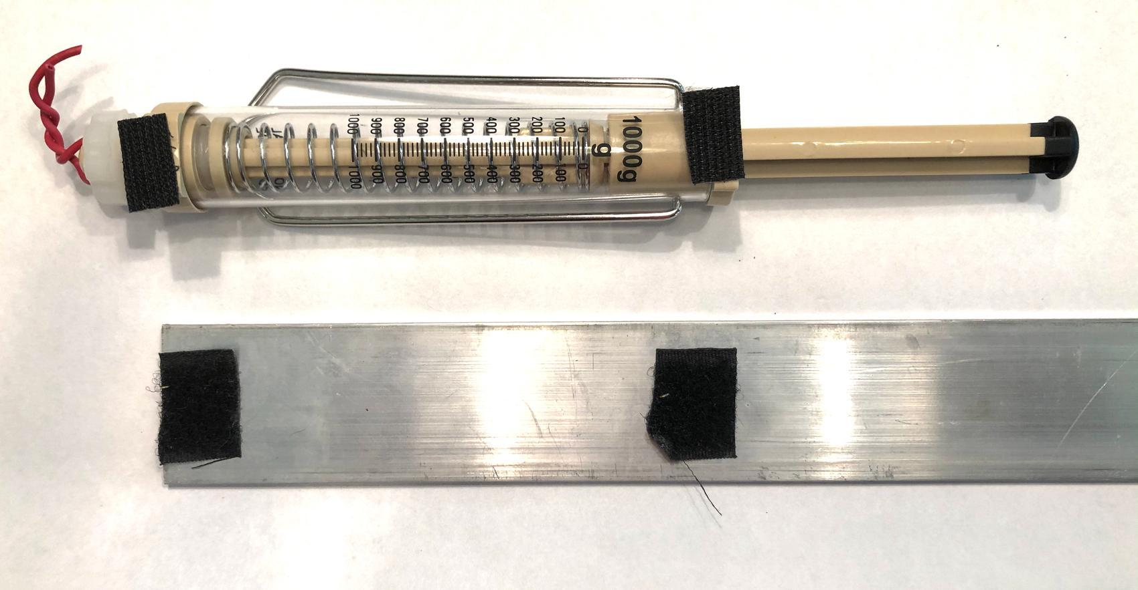
Day 1: Damage from Doubling Mass vs. Speed Lab
- Group size: Make groups 3-5 students
- Setup
- Attach the fuzzy side of hook and loop fasteners stuck to each 10N push-pull spring scale per group. Attach two corresponding pieces of the rough side of hook and loop fasteners to one end of each track at the same distance apart as the fasteners on the spring scales. Remove the hook from the push-pull spring scale and replace it with a twisted piece of wire, as you did for the 5N push-pull spring scales in lesson 5.
- Mount the 10N push-pull spring scale on the track. Tape the end of the track to a table top or to the smooth side of a 4 ft. long piece of laminate flooring.
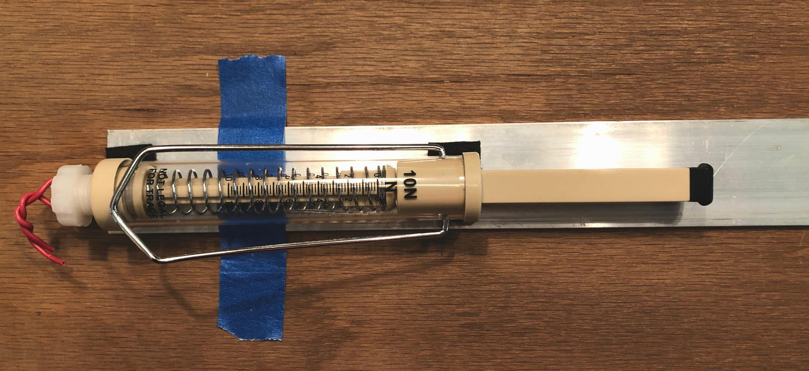
- Test the results produced by investigation 1, described on Procedure for Investigation 1, to ensure that the cracker does get damaged at least in condition C. The investigation as written assumes using a generic soda cracker, which cracks relatively easily. But there are other crackers that might crack even easier, such some brand name crackers with “crispy & thin” designations. You may want to try those in place of generic soda crackers. Fresh crackers damage more easily than stale ones, and high-humidity environments can prevent damage from occurring on the crackers. If this happens to you, there are two suggested options to remedy this:
- One option is that you can boost the strength of the spring scale launchers by a factor of 2 by mounting two 10N push-pull spring scales side by side on the track.
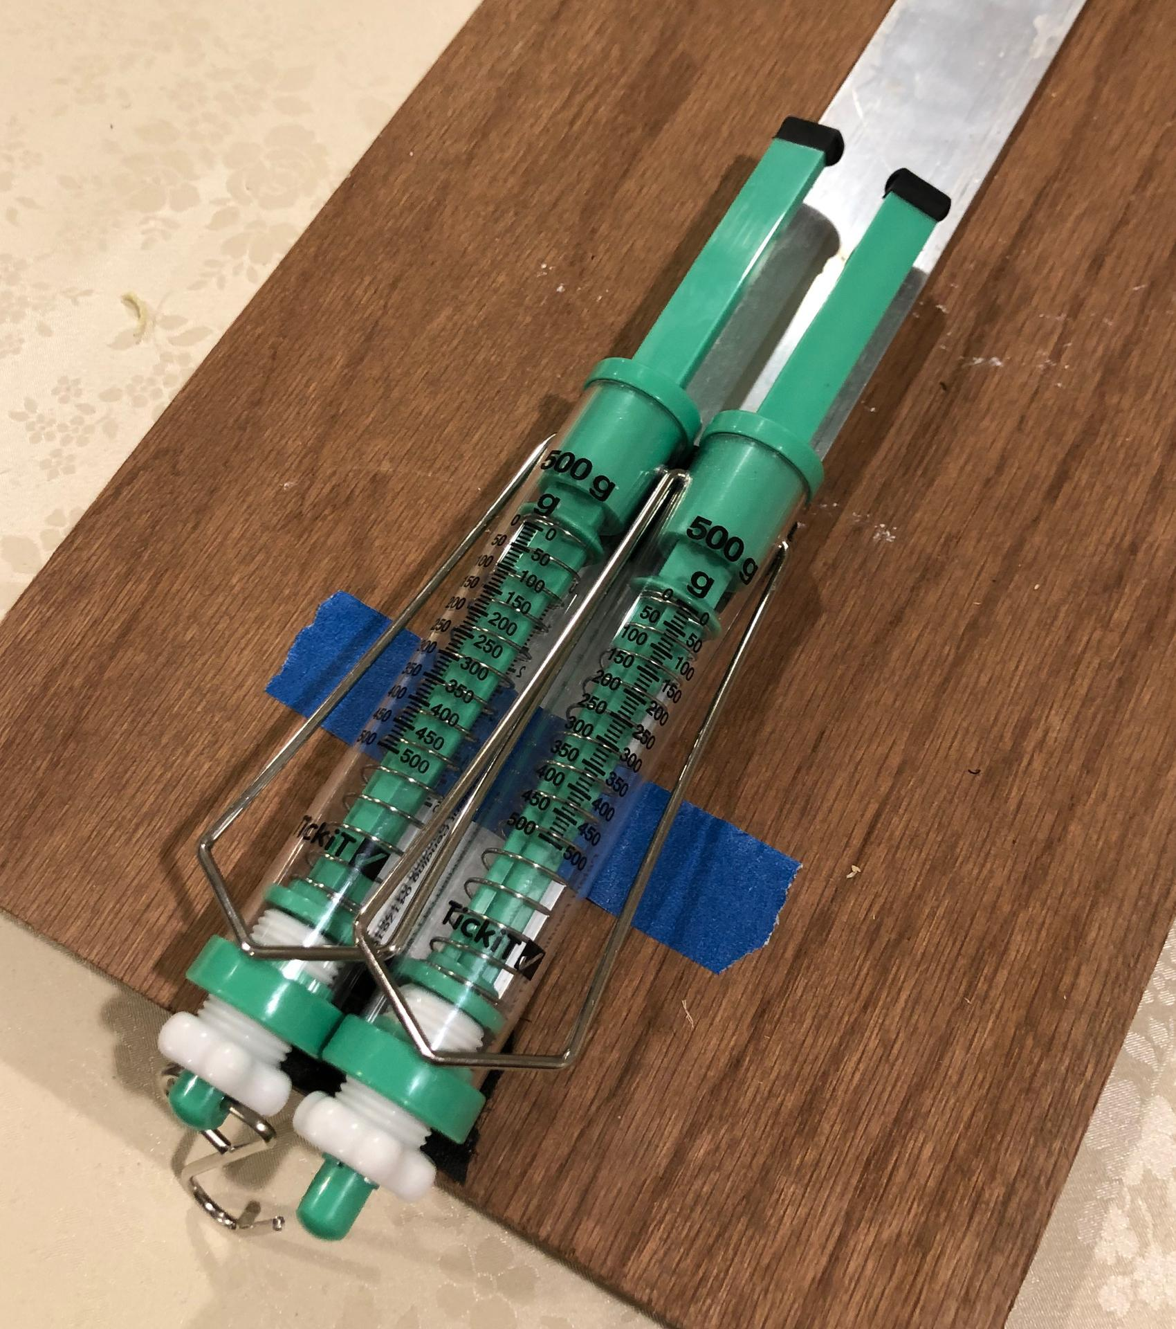
- A second option is to swap in a stronger spring scale. If you do this, change by the same scale factor the corresponding amounts that students should use to launch their carts in conditions A B, and C. For example, if you swap in a 20N push pull spring scale for a 10N one, double the launcher force values from 5N, 7N, and 10N to 10N, 14N, and 20N respectively in Procedure for Investigation 1.
- Safety:
- Wear safety goggles or glasses during the setup, hands-on, and take-down segments of the activity.
- Never eat any food items used in a lab activity.
- Make sure all other fragile items are removed from the test area.
- Secure loose clothing, remove loose jewelry, wear closed-toe shoes, and tie back long hair.
- Immediately pick up any items dropped on the floor so they do not become a slip/fall hazard.
- Follow your teacher’s instructions for disposing of waste materials. Wash your hands with soap and water immediately after completing this activity.
- Storage: Discard used crackers in the trash. Unused crackers tend to go stale and do not crack as easy when this happens. Recycle used paper. All other materials can be stored and reused indefinitely.

Lesson 7 • Where We Are Going and NOT Going

Where We Are Going

In day 1 of this lesson students are introduced to the idea that experiments are not required to have only a single independent variable. Rather, the goal is always to keep careful records of which variables you intend to keep the same between different conditions and which you are not, as this can allow you to ensure that only one variable is changing between at least 2 conditions that you are testing. They then use this approach in the investigation they carry out. This deepens their understanding of the practice of planning and carrying out investigations.

In day 1 of this lesson students are reminded how quantitative data can be graphed to determine whether the relationship between the independent variable and the dependent variable is linear or not, in reference to the work they did in Lesson 4. They will engage in this sort of graphing and data analysis using the data they collect from a computer simulation on day 2 of this lesson. And the related mathematical thinking, where they determine scale factors to describe how much the y values and corresponding x values change between different conditions, will help prepare them for the type of quantitative data analysis and mathematical thinking they will need to do again in the Lesson 9 assessment. These experiences are helping students develop fluency engaging in the practices and using the related crosscutting concept (scale, proportion, and quantity) for meeting MS-PS3-1: Construct and interpret graphical displays of data to describe the relationships of kinetic energy to the mass of an object and to the speed of an object.

There are multiple connections to make to the prior work students have done in math class regarding grade 6 and grade 7 CCS math standards and to how you can help students develop and use CCC3: scale, proportion, and quantity related to the target lesson-level performance expectations.

To support using the crosscutting concept of scale, proportion, and quantity in this lesson you will help students calculate and use a type of ratio called a scale factor. Students will have encountered this concept before in math class when engaging in work around these two learning goals from the CCS for mathematics in 7th grade:
- 7.G.A.1 Solve problems involving scale drawings of geometric figures, including computing actual lengths and areas from a scale drawing and reproducing a scale drawing at a different scale.
- 7.RP.A.2 Recognize and represent proportional relationships between quantities.

There are multiple connections to make to the work students will be doing in math class this year in grade 8 CCSS for math and to how you can help students develop and use SEP4 (analyzing and interpreting data) related to the target lesson-level performance expectations. Since students may develop and use these related concepts in math class later in this year, it is recommended you coordinate with the grade-level math teacher to determine when students will be doing such work so that you know what examples you can draw from or whether such work comes later in the year.

When students describe and compare the qualitative relationships between the mass of a moving object and its kinetic energy and the speed of a moving object and its kinetic energy they are developing and using ideas related to this current-grade math standard:
- 8.F.B.5 Describe qualitatively the functional relationship between two quantities by analyzing a graph (e.g., where the function is increasing or decreasing, linear or nonlinear).

When students describe and compare the quantitative relationships between speed of a moving object and its kinetic energy they are developing and using ideas related to this current-grade math standard:
- 8.EE.A.1 Know and apply the properties of integer exponents to generate equivalent numerical expressions.

Students will be working with squared relationships and cubed relationships in mathematics in 8th grade. They will be developing and working with expressions and equations that represent these relationships in symbols, particularly in the context of geometry, with their work on the Pythagorean theorem and determining the volume of cones, cylinders, and spheres.

Students start connecting new ideas about the relationship between forces applied to objects and changes in their kinetic energy. In investigation 1, they collect evidence that relates the amount of force needed to move an object to its mass and its change in speed, both of which determine that object's kinetic energy. In investigations 2 and 3, they collect evidence that objects with more kinetic energy need to be pushed more (over a longer distance) to get them to stop moving compared to objects with less kinetic energy.

Where We Are NOT Going

When students compare the relative amount of kinetic energy an object has by determining how far a cart can push a box it collides with and maintains contact with across a surface, they are using relationships that are part of the work-energy theorem. This theorem describes the quantitative relationship between the change in kinetic energy of an object and the force applied over a distance on that object. That quantitative relationship is not a focus of the unit and is beyond the grade-band learning targets. But, establishing a qualitative relationship between the net force applied to an object and how much this changes an object's motion (and the kinetic energy it has) is a focus of the unit. The source of that force (the friction between the box sliding over the track) is introduced in the next two lessons. But the fact that the strength of this friction force when the box is sliding is nearly constant is not addressed in this unit.

No attempt is made to assign units to the amount of energy an object has. The focus of this lesson is on the relative changes in amount of energy in terms of scale factors, which are unit independent. The simulation that students use is https://www.openscied.org/collision2-simulation/.

The focus of this lesson is not on developing an equation that relates the kinetic energy of an object to both its speed and its mass together. Such an equation (kinetic energy = ½ mass x velocity²) is a high school learning target for PS3.B. In high school students will need to develop mathematical expressions, which quantify the amount of energy in different parts of a system in order to develop and use models that account for the idea that total change of energy in any system is always equal to the total energy transferred into or out of the system. This lesson lays the groundwork for that equation but avoids going into that territory as it is well beyond the appropriate learning targets for 8th grade CCS in mathematics as well.

LEARNING PLAN for LESSON 7
1 · NAVIGATION | 5 min
MATERIALS: chart paper, markers
Summarize what we figured out so far. Say, Let’s remind ourselves what we figured out so far and where we think we need to head next. Show slide A. Discuss the questions on the slide as a whole class. This can be a quick check-in on the set of ideas the class should already be in consensus about.  Connect to the areas of disagreement in the predictions students shared last time and how we might go about investigating our competing predictions.  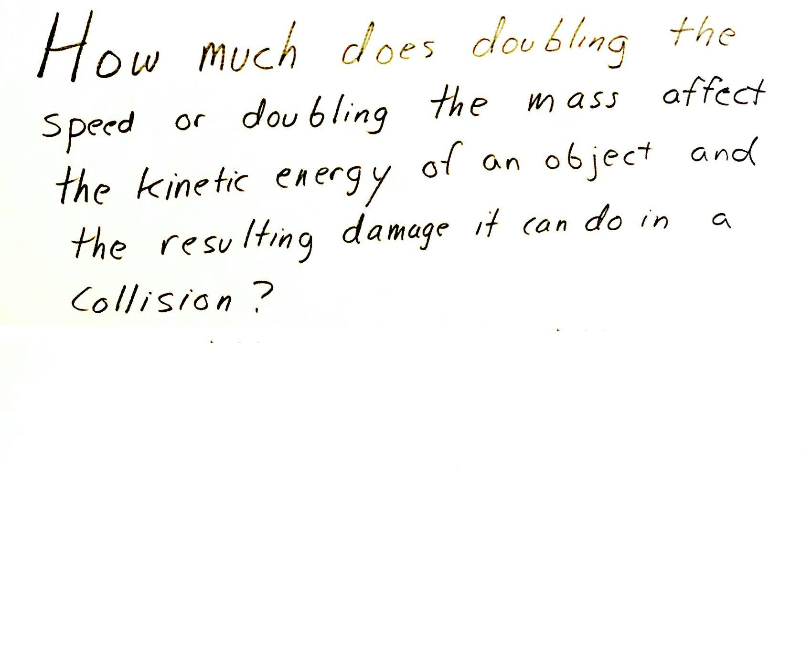  Say, So if we weren’t in agreement on our predictions related to this question, we will need some data in order to resolve this question about whether changes in mass or changes in speed have a bigger effect on the kinetic energy of a moving object and the damage it can do in a collision. Let’s think through what we will need to do to collect that kind of data from an investigation using our cart system in order to try to answer this question.  Write this question on chart paper:  - How much does doubling the speed or doubling the mass affect the kinetic energy of an object and the resulting damage that it can do in a collision? | ✱ SUPPORTING STUDENTS IN ENGAGING IN PLANNING AND CARRYING OUT INVESTIGATIONS  Though students have planned other investigations before identifying the independent and dependent variables in an investigation they will benefit from seeing you develop an anchor chart for identifying the variables in this investigation. This is because the form of this investigation, where there is more than one independent variable to investigate and where students are going to change the value for more than one independent variable within a single investigation, is something they have not thought through in prior OpenSciEd unit investigations. Since the procedure for this investigation is relatively complex and is already provided for students and this is the first example of a multi-independent variable approach to an investigation that students will have seen, this is not a place where it would be worth having students develop the investigation plan on their own. Instead, have students focus on contributing to the discussion in the next section about the variables in the investigation and ways to ensure that the spring-scale launch method can be calibrated to produce more-reliable results.
  Suggested prompt | Sample student response
  How does increasing either the speed or the mass of a moving object affect its kinetic energy? | Increasing either the mass or the speed of an object increases its kinetic energy.
  How do such changes affect the peak forces in a collision between that moving object and a stationary object? | They increase the peak forces on both objects.
  How would such changes affect the amount of damage done in a collision? Why? | It should increase the damage if the peak forces exceed the elastic limit.  It should increase the amount of shape change or the amount of permanent deformation.  It may lead to it breaking into pieces if the peak forces are greater than the breaking point of the object.
  Suggested prompt | Sample student response
  Were we in agreement about whether doubling the mass or doubling the speed of a moving object has a bigger effect on the kinetic energy of a moving object? | No.
  What were some of our different predictions? | Some of us thought doubling the mass would have a bigger effect, and some of us thought doubling the speed would.  (Some students may say that they would have the same effect.)
  How could carrying out an investigation where we compare the amount of damage done in two different collisions help us figure this out? | If something with twice as much mass does just as much damage as something with twice as much speed, then they must have the same amount of kinetic energy.  If doubling the mass results in more damage than doubling the speed, then increasing mass has a bigger effect on kinetic energy than doubling the speed.  If doubling the speed results in more damage than doubling the mass, then increasing speed has a bigger effect on kinetic energy than doubling the mass.

2 · PLANNING OUR INVESTIGATION | 12 min
MATERIALS: science notebook, Changes in Kinetic Energy: Investigations #1 & 2, chart paper with investigation question, markers
Identify independent variables. Ask students what variables we will need to change in an investigation that answers the question recorded on the chart paper. Students should say the mass and the speed of a moving object.  Introduce the idea that we can have more than one independent variable we want to investigate. Say, In your experiences in science so far, you’ve had a lot of experience planning and carrying out investigations where only a single independent variable is changed at a time and you are trying to keep all other variables constant. This is often a very useful way to approach the design of an investigation since it tends to allow for more straightforward data analysis after you collect your data. This is particularly true when the data you are planning on collecting are quantitative and you want to graph it afterward to see if there are any interesting trends in it, such as whether the relationship between the independent and dependent variable is linear or not. You did something like this in Lesson 4 when you graphed the results from your force versus deformation investigations of wood stirrers and foam.  Ask students which variables they put on which axis in that case and why. If needed, you can prompt students to look back in their notebook to Deformation Results where they graphed these data.  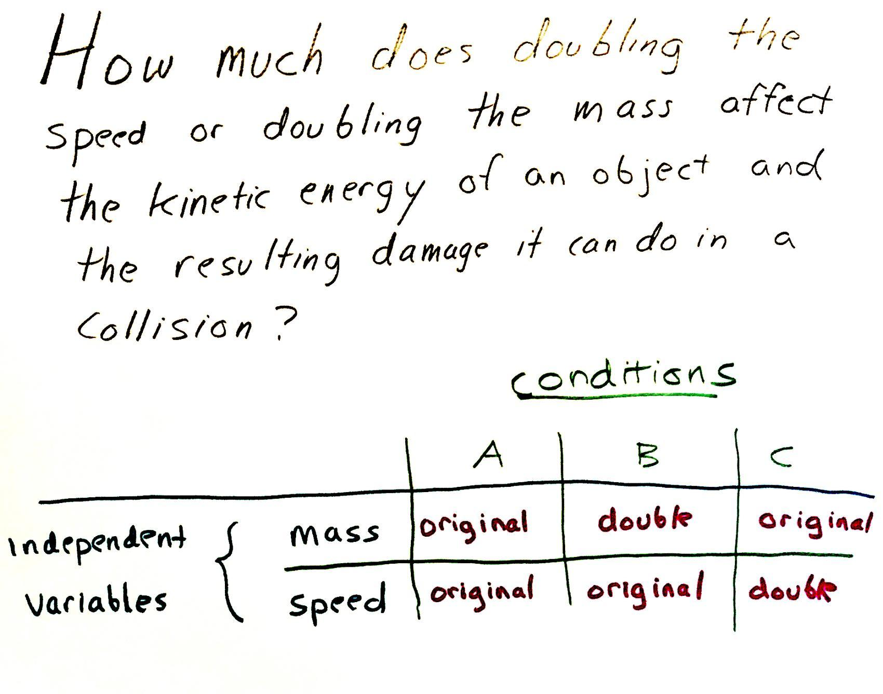  Continue explaining ways you can extend this approach to cases where you have more than one independent variable to investigate. Say, In such cases like the one you just described from Lesson 4, you are able to see interesting trends in the data on a coordinate graph. As our investigations become more complex, we may sometimes find that we have more than one independent variable we need to change. In such cases it will be helpful to use a table to keep track of all the conditions we plan to test before we carry out our investigation so that we can identify which variables we are trying to keep constant between different conditions and which we are not. Let’s create a table to help us keep track of this for our investigation.  Add the following table to the chart paper on which you recorded the question being investigated.  Use the suggested prompts below to have students think about what would be an important variable to keep constant between the different conditions and how one could measure it to ensure that this variable doesn’t change.  Summarize that this is an example of building a table to keep track of the variables that we plan to change in each condition we plan to test and that this can help us recognize which variables are important to keep constant between each condition.  Distribute Changes in Kinetic Energy: Investigations #1 & 2. Instruct students to add this to their science notebooks to record their data in later.  Show slide B. Say, Because you need a repeatable way to launch the cart at the same speed in condition B as you did in condition A, we are going to use a spring scale as a launcher. Let’s think about how using a spring scale as a launcher can help us do that.  Ask the following questions to raise issues related to the spring scale’s use, the accuracy of the launch method, and the need to calibrate the system.  Motivate the need for multiple trials and calibration for each condition based on these possible sources of error. Say, The sources of error we’ve identified mean that before adding the damage target, the cracker, to the setup you will want to do a few trials to make sure you are confident that the speed of the launch isn’t changing when you launch the cart from the same launch position every time.✱ Follow the procedure you will receive as it will describe this in more detail and will provide you steps on how to ensure that you capture all the pieces that might fall off the damaged object, the cracker, on a piece of paper under the brick. An image of this is shown on the slide. | ✱ SUPPORTING STUDENTS IN ENGAGING IN ANALYZING AND INTERPRETING DATA  Though this summary and related recall of what students did in Lesson 4 is an important one to do at this point in the lesson as it not only reminds students how quantitative data can be graphed to determine whether the relationship between the independent and dependent variables is linear or not, it is also foreshadowing something that students will argue for doing with the data they collect from the computer simulation in day 2 of this lesson. And it also helps students understand that this is one important trade-off to consider in whether you design an investigation so that it has only one independent variable, which lend themselves to mathematical models that can be derived from quantitative data vs. designing the investigation so that it has more than one independent variable, which allows for comparing the relative impact of many different factors on a particular outcome.  ✱ SUPPORTING STUDENTS IN ENGAGING IN PLANNING AND CARRYING OUT INVESTIGATIONS  In this investigation, students are provided a method for calibrating the system. This is part of building progression for this practice that comes together in lesson 12, where students carry out an investigation where they must figure out how to calibrate their system themselves for a control condition that all other groups are also using, and which they will use to gather data on a unique material they are testing and reporting out the results for.
  Suggested prompt | Sample student response
  If we want to investigate how doubling the mass affects damage in a system, how would we measure its mass to ensure that we have made this change to the system? | Using a digital scale.
  If we want to investigate how doubling the speed affects damage in a system, how would we measure or calculate its speed to ensure that we have made this change to the system? | Use a timer and measure how far it goes in a certain amount of time.  You can divide the distance the cart travels by the time it takes to travel that far to determine its speed.✱
  SUPPORTING STUDENTS IN MAKING CONNECTIONS IN MATH | Working with unit rates and ratios is within the 6th and 7th grade Common Core Math Standards. By the beginning of 8th grade, students should be well versed in how to do this calculation. If students struggle with coming up with using unit rates to figure out how to measure speed, you may need to prompt them and support them in finding this calculation.
  Suggested prompt | Sample student response
  What was the independent variable that you plotted values for along the x-axis of your graph? Was it the force you applied to the material or how much the material deformed? | It was the force we applied to the beam.
  And then when you plotted the corresponding deformation on the y-axis, what sort of relationship did we see? | It was linear.
  ALTERNATE ACTIVITY | 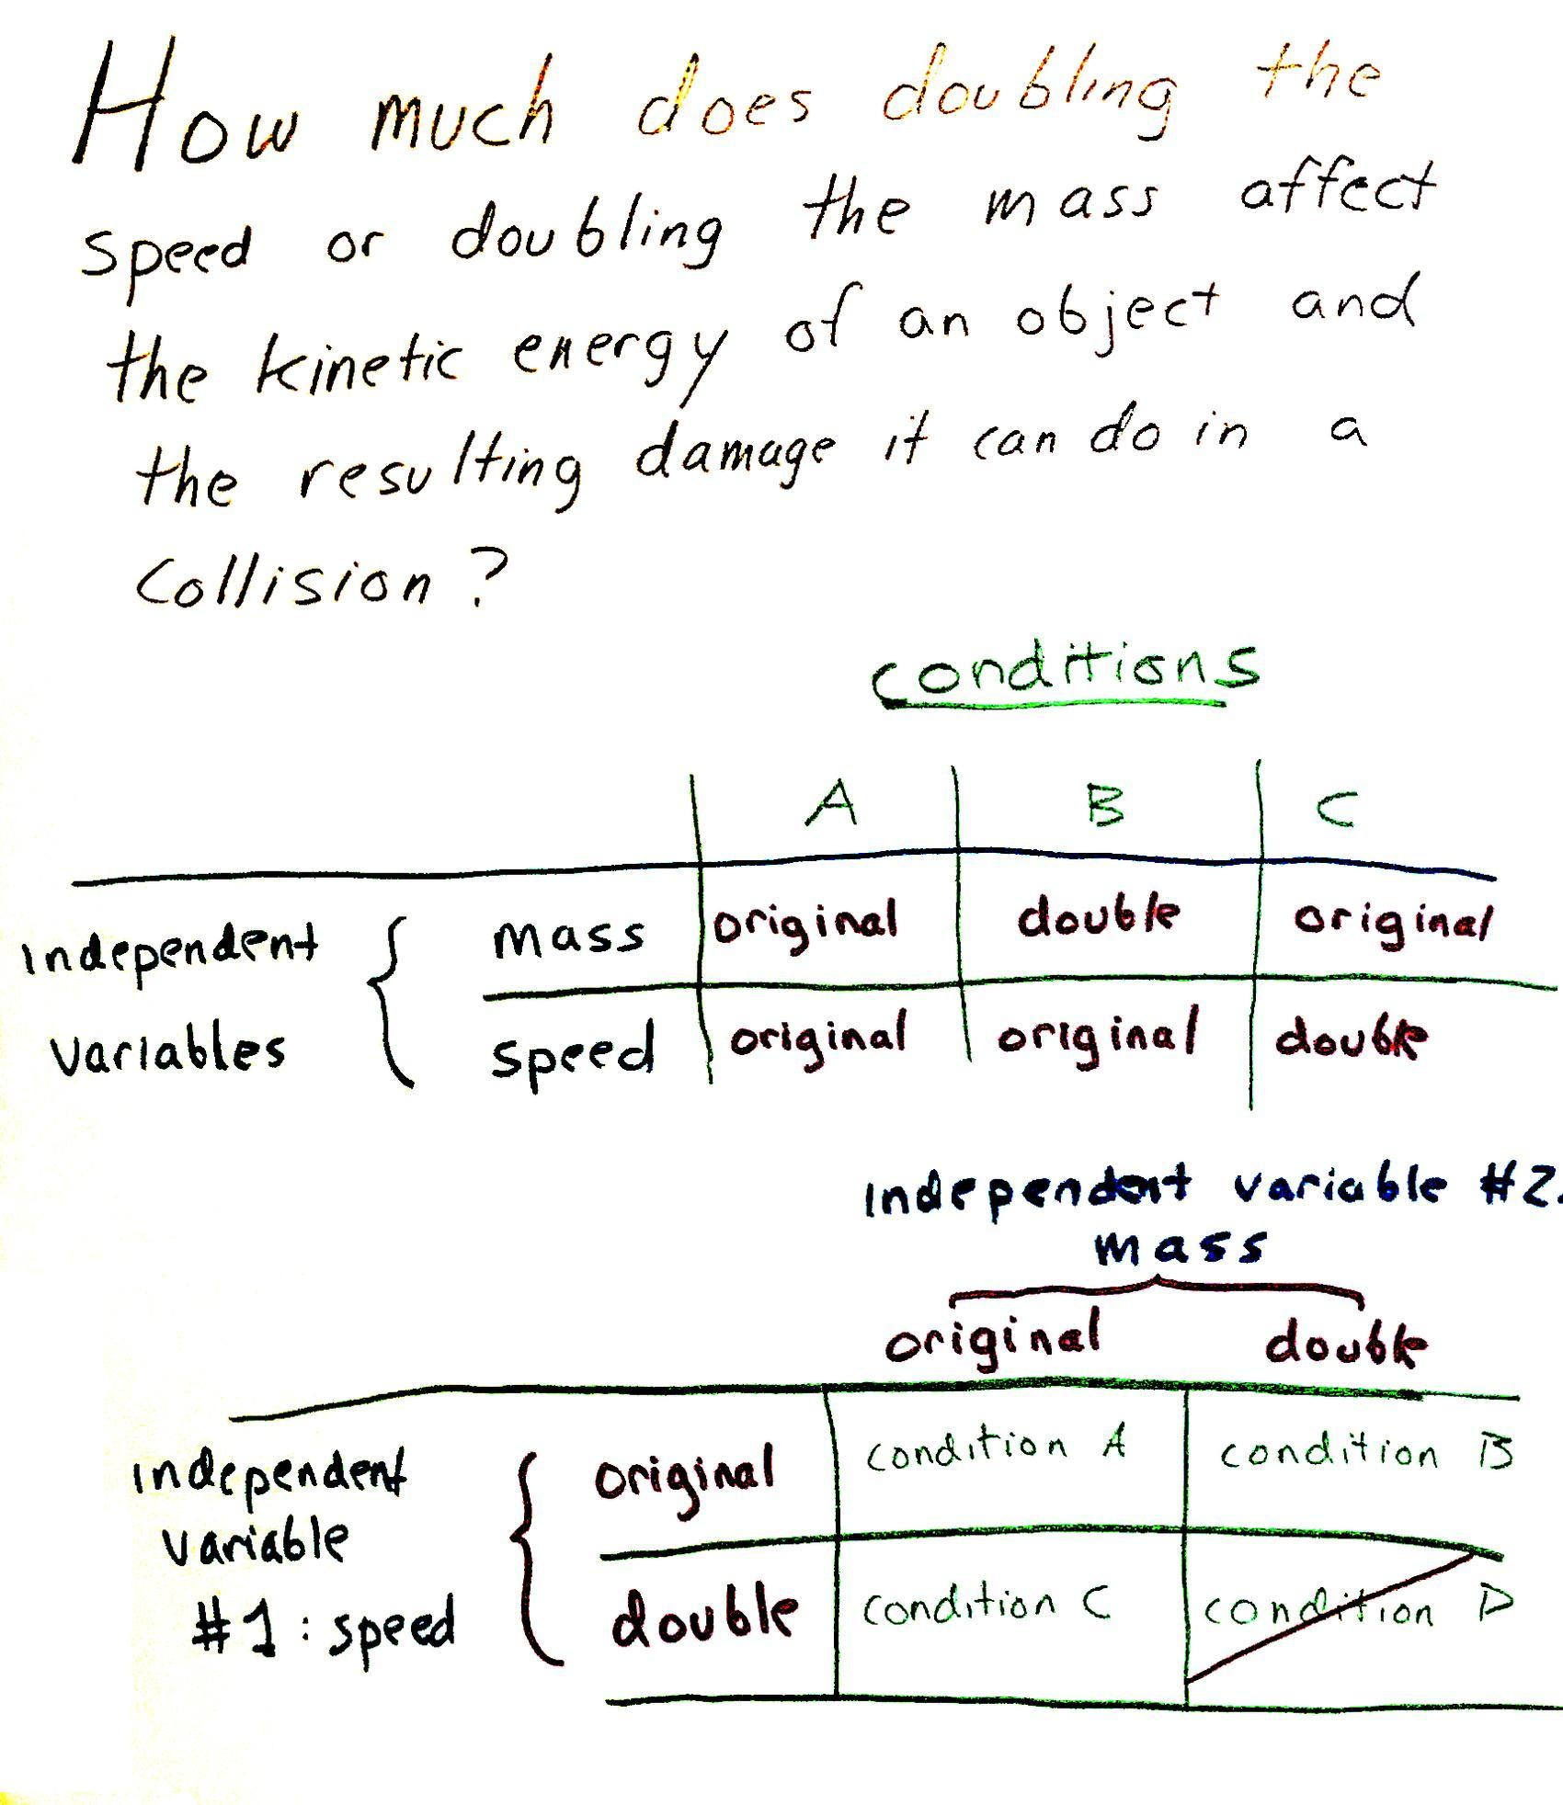  The most common approach to investigating the effects of multiple independent variables in an experiment is called factorial design. In a factorial design approach, each level of one independent variable (which can also be called a factor) is combined with each level of the others to produce all possible combinations. In this context, doubling mass and speed would result in testing four conditions, the three outlined in the table below as well as a fourth, where both the mass and the speed are doubled. But in the context of the question students are investigating it doesn’t make sense to test that fourth condition as well. This is what a factorial design approach for this investigation would look like, in case you want to demonstrate how to set up the additional table on the bottom of the poster to support this approach
  Suggested prompt | Sample student response
  What would be an important variable to keep constant between conditions A and B. | Speed.
  What would be an important variable to keep constant between conditions A and C. | Mass.
  So how many variables are we changing between conditions B and A? Which one is it? | One. The mass.
  How many variables are we changing between conditions C and A? Which one is it? | One. The speed.
  Suggested prompt | Sample student response
  If you push the cart against the spring scale and hold it at that position and then release it, what do you expect to see the cart do? | It will move down the track.
  If you repeat what you did so that you push the cart against the spring scale just as far as the previous time and hold it at that position and then release it, how should its motion compare to the previous launch? | It should move down the track in the same way.  It should launch it at the same speed.
  What are some sources of error in this system that might cause it to not launch at exactly the same speed each time you release it from the same position as before? | You might not be putting it at exactly the same position as before.  You might have forgotten to zero the scale.  Your fingers might get in the way of the release.  There might be stuff on the track that gets in the way.
  What might be some sources of error when comparing the damage results? | Crumbs might break off and they aren’t part of the damage.  You might lose track of the pieces that break off.
  ALTERNATE ACTIVITY | The cracker shown on the side is a generic soda cracker. It cracks relatively easily. But there are other crackers that might crack even easier, such as some brand name crackers with “crispy & thin” designations. You may want to try those in place of generic soda crackers. If you do, you can swap in a new photo on this slide showing these new crackers in place of the default one on the slide.

3 · CARRY OUT AN INVESTIGATION ON DAMAGE FROM DOUBLING MASS VS. SPEED | 14 min
MATERIALS: Damage from Doubling Mass vs. Speed Lab, science notebook, Procedure for Investigation 1, Changes in Kinetic Energy: Investigations #1 & 2
Show slide C. Distribute Procedure for Investigation 1 to students. Point out where in the room you want students to bring their damaged test objects (broken crackers and the index cards they were attached to with sticky putty and the papers used to collect the related debris from these crackers) at the end of their investigation, such as a back table or counter. Ideally this is a place students can either pull their chairs around or gallery walk along to be able to see the results. The purpose here is to provide them a space where everyone can do a quick glance over multiple sets of results quickly.

SAFETY PRECAUTIONS   | Remind students of safety considerations. Students should wear impact goggles during this investigation.

Monitor groups as they carry out investigation 1 following the procedure on Procedure for Investigation 1.

4 · ARGUE FROM EVIDENCE FOR WHICH FACTOR AFFECTS KINETIC ENERGY MORE | 4 min
MATERIALS: None
Argue for what the data show us. Gather students around the pooled class results (crackers on paper) or give them a couple minutes to do a gallery walk past all the collected results. Ask students to study the results and be prepared to make an argument for the answer to this original question based on our results:
- How much does doubling the speed or doubling the mass affect the kinetic energy of an object and the resulting damage that it can do in a collision?

Briefly discuss what the data tell us. Students will argue that doubling the speed of a moving object has a bigger effect on its kinetic energy, which causes it to have a greater amount of damage. Ask multiple students to weigh in on how the evidence supports this conclusion. Students should say that objects from condition C (doubling the speed) show more damage (more pieces and/or more cracks) in them than the same objects from condition B (doubling the mass).

ADDITIONAL GUIDANCE | Students may also note that this may be because the spring scale was pulled back further in condition C than in condition B. The lesson, as written, plans for students to start thinking about the qualitative relationship between changes in the maximum force from the launcher on the cart and the amount of energy transferred to the cart subsystem at the end of the lesson, rather than now. But if students spontaneously raise these noticings now during the investigation, follow up with additional questions in the moment to encourage additional reasoning about what they notice. Suggested prompts include the following:  - What does this tell you about the relationship between the force needed to move an object and its mass?  - What does this tell you about the relationship between the force needed to move an object and its speed?  - What does this tell you about the energy needed to get a stationary object to speed up twice as much as compared to getting an object to move at the original speed with twice as much mass?  - What does this tell you about which object might take more force to slow to a stop? (This question will help students anticipate the results from investigation 2.)

5 · ANALYZING DATA FROM A QUANTITATIVE MEASURE OF ENERGY TRANSFER | 12 min
MATERIALS: science notebook, Changes in Kinetic Energy: Investigations #1 & 2, computer, projector, https://youtu.be/ygLbCFuqYFo, https://youtu.be/XgczgVAiCYk, https://youtu.be/3Rzt0wNQAT0
Problematize the unanswered part of our question (quantifying “how much”). Say, Though we can use our observations to argue that doubling the speed of a moving object has a greater effect on its kinetic energy than doubling its mass, our original question we were investigating was asking us “How much does doubling the speed or doubling the mass affect the kinetic energy of an object and the resulting damage that it can do in a collision?” Knowing how much of an effect one thing is having on something else can be answered through simply ranking our results to determine which thing has a bigger effect. But knowing specifically how much more is not something we can say unless we have some sort of way to quantify all the variables that are part of this question. We have a way to quantify the mass and speed of an object, but we don’t have a way yet to quantify the amount of kinetic energy that object has.

Introduce the potential advantages of a quantitative measure of kinetic energy. Say, Finding a way to quantify how much kinetic energy an object has when we change its mass or its speed could provide us another tool for explaining why some things get damaged in a collision and others don’t. It could also help us more precisely predict the amount of damage a moving object could do and maybe even give us ideas about ways to design solutions to prevent such damage from happening.

ADDITIONAL GUIDANCE | This is the first time you will have raised the suggestion of designing solutions to prevent damages in a collision. This is designed to start foreshadowing the direction of Lesson 9 and beyond in the unit.

Introduce a way to quantify the relative amounts of kinetic energy an object has. Say, Scientists and engineers have developed different ways to measure and compare how much more kinetic energy one object has compared to another. One of those ways is to measure the entire distance over which two objects push on each other during a collision. This method involves colliding the moving object into a stationary object in such a way that the object that was moving remains in contact with the object it collided with and continues to push it along a surface until both have stopped moving, without causing any damage. Let’s see what an example of this method looks like.

Orient students to an example of such a measurement by showing this video clip: https://youtu.be/ygLbCFuqYFo.

Share likely sources of error in the system. Say, We have seen the result from only one trial for one condition. If the person who made this video ran multiple trials for this one condition, using the same mass and speed each time, why might it be reasonable to still expect that there would be some amount of variation in how far the box is pushed in each trial? What might cause that variation? Anticipated responses will reference sources of error students mentioned earlier in the lesson.

Say, If we know there might be slight variation in the results, let’s look for some really general patterns in the data from just one trial of the same three conditions we collected data on with our first investigation.

Show slide D. Explain to students that you will show the video again and that they should prepare to record the related data for investigation 2 on Changes in Kinetic Energy: Investigations #1 & 2. Show the video for condition A again: https://youtu.be/ygLbCFuqYFo. Pause the video as needed. Give students a minute to record the related data.

Show slide E. Have students turn and talk about the questions on the slide. ✱
- When we double only the mass of the cart, how much further will it push the box?
- When we double only the speed of the cart, how much further will it push the box?

ALTERNATE ACTIVITY | If time is short, you can pause the end of the first day of the lesson here on a cliff-hanger and tell students that we will collect the remaining data to check our predictions next time. If you do this, carry over the video analysis as well as the discussion of predicting the effects of tripling the mass or speed of the cart from slide G to the start of the next day.

Show and record data from the related videos. Show slide F.
- Show video 2: https://youtu.be/XgczgVAiCYk. Give students a minute to record the related data in their investigation 2 data table on Changes in Kinetic Energy: Investigations #1 & 2.
- Show video 3: https://youtu.be/3Rzt0wNQAT0. Give students a minute to record the related data in their investigation 2 data table on Changes in Kinetic Energy: Investigations #1 & 2.

These are all the values that students will end up recording in their data table for investigation 2:

The same spring-scale launcher position (force in N)
were used for these conditions as were used in investigation 1
 | Condition A | Condition B | Condition C
mass (g) | original:  64.2 | double:  128.4 | original:  64.2
average cart speed (cm/sec) | original:  93 | original:  93 | double:  186
distance the box was pushed before  coming to a stop (cm) | 10.2 | 20.4 | 40.5

Show slide G. Have students turn and talk about the questions on the slide. Give three minutes for this discussion:
- About how many times further did the box get pushed when the mass was doubled?
- About how many times further did the box get pushed when the speed was doubled?
- What does this tell us then about how much more kinetic energy the cart had in each case?
- Based on these patterns, make a new set of predictions:
- If you tripled only the mass of the cart, how many times further will it push the box?
- If you tripled only the speed of the cart, how many times further will it push the box?

Summarize that we will revisit these predictions next class to help us develop a mathematical model for quantifying the amount of kinetic energy an object has in order to be able to more accurately predict and explain what causes damage in some collisions and not others.

End of day 1

6 · NAVIGATION | 5 min
MATERIALS: science notebook, Changes in Kinetic Energy: Investigations #1 & 2
Show slide H. Cue students to look back at the results they recorded for investigation 2 on Changes in Kinetic Energy: Investigations #1 & 2. Discuss the questions on the slide.  Connect to the idea of scale factors from math class. Say, When you are saying you predict the new value compared to the old value will be 3 times more or 6 times more, you are describing the ratio of the new value to the old value as a scale factor.  Motivate the need for a mathematical model. Say, Notice that just one set of results is allowing us to make more mathematically precise predictions about the effects of scaling up the mass or speed by a different scale factor than 2. More data could help us develop an even more general mathematical model so that we can accurately predict how any change in the mass or change in the speed of a moving object would affect its kinetic energy. But to develop such a general mathematical model we are going to need more data.  Problematize the limitations of the setup shown in the video. Emphasize that the track we used is only a meter or less long and that is true of the track we saw in the video too, so in our classroom space and with the limited supplies we have, we would run out of space and/or track if we keep increasing the kinetic energy of the cart and try to see how far it pushes the box.  Recall previous examples where students used computational simulations study. Say, You’ve seen many cases in your previous science work when you were limited in your ability to study the entire system in some way. Sometimes when this happened, you switched to using a computational simulation to collect additional data. What were some of the systems you’ve studied where you’ve used a computational simulation to collect additional data about the system?  Students will say things like these:  - particle collisions in Cup Design Unit  - absorption of food in the small intestine in Inside Our Bodies Unit  - photosynthesis in the chloroplasts of a leaf in Maple Syrup Unit  - orangutan ecosystem interactions in Palm Oil Unit | ✱ SUPPORTING STUDENTS IN DEVELOPING AND USING SCALE, PROPORTION, AND QUANTITY  To support using the crosscutting concept of scale, proportion, and quantity in this lesson you will refer to an idea from mathematics called a scale factor. Students will have encountered this concept when engaging in work around two related learning goals from the CCS for mathematics in 7th grade. In this lesson, scale factors are used to describe the ratio of two different masses or two different speeds or two different amounts of kinetic energy. So for example, doubling any amount of mass would mean the ratio of the new mass to the old mass is 2, which is the scale factor. Halving the speed would mean the ratio of the new speed to the old speed is 0.5, which is the scale factor. Predicting and ultimately discovering how such changes affect the corresponding scale factor for kinetic energy (the ratio of the new kinetic energy to old kinetic energy) is the key discovery students will be making in the next investigation.
  Suggested prompt | Sample student response
  About how many times further did the box get pushed when the mass was doubled? | About twice as far.  Doubling the mass almost doubled the distance the box was pushed (compared to condition A).
  About how many times further did the box get pushed when the speed was doubled? | About four times as far.  Doubling the speed almost quadrupled the distance the box was pushed (compared to condition A).
  What does this tell us then about how much more kinetic energy the cart had in each case? | It had double the kinetic energy when we doubled its mass, but it had four times as much kinetic energy when we doubled its speed.✱
  Based on these patterns, what predictions did you and your partner make about the following: If you tripled only the mass of the cart but kept its speed the same, how much further will it push the box?  If you tripled only the speed of the cart but kept its mass the same, how much further will it push the box? | Tripling its speed would push the box six times as far, but tripling its mass would push it only three times as far.  Tripling its speed would push the box nine times as far, but tripling its mass would push it only three times as far.
  ADDITIONAL GUIDANCE | Listen for this key idea, as helping students see that the relative increase in the distance the box is pushed is a measure of the relative increase in the kinetic energy of the object.

7 · PLANNING FOR USING A COMPUTATIONAL SIMULATION | 5 min
MATERIALS: science notebook, 2 copies of Graphing Kinetic Energy Relationships, optional: 1 copy each of Alternate: Graphing Mass vs. Kinetic Energy and Alternate: Graphing Speed vs. Kinetic Energy, computer, projector, https://www.openscied.org/collision2-simulation/
Introduce the computational simulation students will use for investigation 3. Say, Let’s prepare to collect some additional data from a computer simulation that will allow us to further explore the relationship between the mass and speed of a moving object and its kinetic energy. First let’s orient ourselves to the interface we will be using.  Demonstrate a model run for the default simulation settings. Load the simulation, located at https://www.openscied.org/collision2-simulation/. After the model loads, press “setup” and ask students what they notice. They will say that they see a cart, a track, and a box.  Press “go/pause” and run the model. Ask students what they notice. They will say that the cart coasted down the track and ran into the box and pushed it a certain distance down the track.  Ask students, using the prompts below, how this simulation would allow us to collect the data we need to answer the question we have been considering.  Set up data collection tables. Show slide I. Distribute two copies of Graphing Kinetic Energy Relationships to each student as students are setting up their science notebooks to collect their data. Ask students why they will need two pieces of graph paper. They will say that they will need one for each data table or one for the effects of speed changes on kinetic energy and one for the effects of mass changes on kinetic energy.✱ | ✱ ATTENDING TO EQUITY  Universal Design for Learning: If you have students who may struggle with setting up a graph, use Alternate: Graphing Mass vs. Kinetic Energy and Alternate: Graphing Speed vs. Kinetic Energy in place of the two copies of Graphing Kinetic Energy Relationships. These two alternate handouts have the axes labeled already for the students and will provide an access point for students who may not know how to do this yet or may struggle with this math skill.
  Suggested prompt | Sample student response
  We were debating the effects of tripling the mass or speed of a moving object on its kinetic energy. How would this simulation allow us to answer this question? | We could triple the mass and see how much further it pushes the box and we could do the same for tripling the speed.
  What is the relationship between how far the box moves and the kinetic energy of the virtual cart? | The distance the box is pushed is a measure of the kinetic energy of the cart.
  In addition to tripling the mass or the speed, let’s remember that we want to get a more complete sense of the mathematical relationship between changes in the mass or the speed and resulting changes in kinetic energy of a moving object. How many different data points do you think you’d need in order to determine what the trend is in a graph of your data? | More than two.  Four.  As many as possible.

8 · COLLECTING AND GRAPHING DATA FROM A COMPUTATIONAL SIMULATION | 15 min
MATERIALS: science notebook, 2 copies of Graphing Kinetic Energy Relationships, optional: 1 copy each of Alternate: Graphing Mass vs. Kinetic Energy and Alternate: Graphing Speed vs. Kinetic Energy, computer, https://www.openscied.org/collision2-simulation/
Provide instructions for investigation and graph creation. Show slide J. Tell students that you want to collect their graphs at the end of the investigation as a formative assessment.

Cue students to launch the simulation (https://www.openscied.org/collision2-simulation/) on their own computers.

Monitor students during the investigation. Seven minutes into the investigation, cue students to start graphing their data if they have sufficient data in their data tables. This will leave eight minutes for developing the graphs, which some students will need, particularly since they are setting up the x-axis and y-axis and related intervals for both graphs on their own.

ASSESSMENT OPPORTUNITY | Building towards: 7.A Construct, analyze, and interpret graphical displays of data collected from a computer simulation to identify patterns in the data, including a linear relationship between the mass of a moving object and its kinetic energy and a nonlinear relationship between the speed of a moving object and its kinetic energy.  What to look for/listen for:  - the y-axis on both graphs labeled as “kinetic energy of the cart (measured as the distance the box is pushed)”  - the x-axis on one graph labeled as “mass” and the x-axis on the other graph labeled as “speed” or additional detail in the labels such as “mass of the moving object for a fixed speed” on the x-axis and “speed of moving object for a fixed mass” on the y-axis.  - some major intervals marked on both graphs  - equal intervals used along each axis  - coordinate data points plotted on both  - a directly proportional pattern [linear and passing through (0,0)] in the mass vs. kinetic energy graph  - a nonlinear (quadratic) pattern curving upward from (0,0) in the speed vs. kinetic energy graph  What to do:  - If you see students assigning the mass or the speed to the y-axis rather than the x-axis, encourage them to reference their graph from Lesson 4 to identify which variable was their independent variable and which axis they put it on in that graph.  - If you see students trying to assign a label to every interval on their axes, suggest they take the approach they see on a metric ruler, where only major intervals are labeled, such as every 10 mm intervals, so that the in-between interval lines are assumed to be 1/10 of the value between each major interval.  - If you see students alter their y-axes scale to go by nonlinear intervals, point out that it's easier to see linear vs. nonlinear patterns in coordinate graphs if the intervals for each axis are always equal along that axis and give students a new piece of graph paper to reset these up on.

9 · ANALYZE AND INTERPRET RESULTS OF OUR INVESTIGATION | 10 min
MATERIALS: science notebook, calculator, 2 copies of Graphing Kinetic Energy Relationships, optional: 1 copy each of Alternate: Graphing Mass vs. Kinetic Energy and Alternate: Graphing Speed vs. Kinetic Energy, chart paper, markers
Show slide K. Give students 4 minutes with a partner to discuss the questions and do the calculations described on the slide. After this, discuss these questions as a whole class.  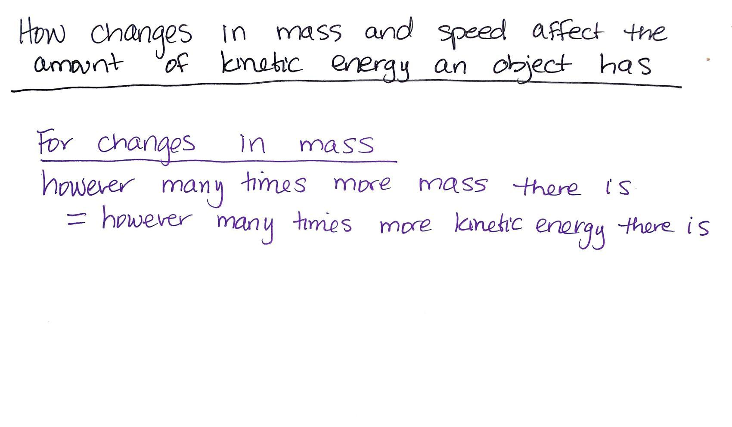  Start an anchor chart where you can summarize the relationships. Say, We can represent that relationship in a general way. Add a title to the poster: “How changes in mass and speed affect the amount of kinetic energy an object has”  Under this add the following:  For changes in mass  however many times more mass there is  = however many times more kinetic energy there is  Ask about scaling down the mass.  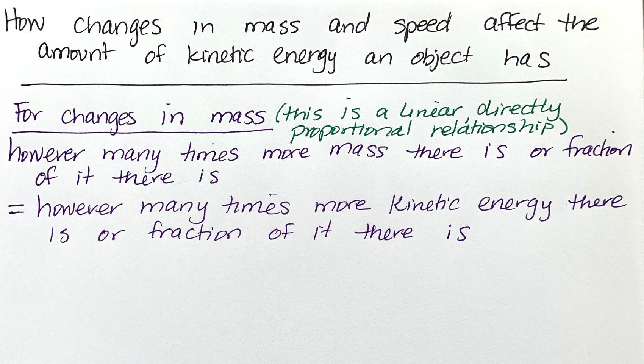  Suggest that what we wrote should also therefore have the phrase “or fraction of it there is” in it to show that we can scale the mass up or down and the amount of kinetic energy scales up or down accordingly. Add this phrase to the statement on the chart paper.  For changes in mass (this is a linear, directly proportional relationship)  however many times more mass there is or fraction of it there is  = however many times more kinetic energy there is or fraction of it there is  Shift to describing and representing the relationship between speed and kinetic energy. Say, What about for the general relationship between speed and kinetic energy?  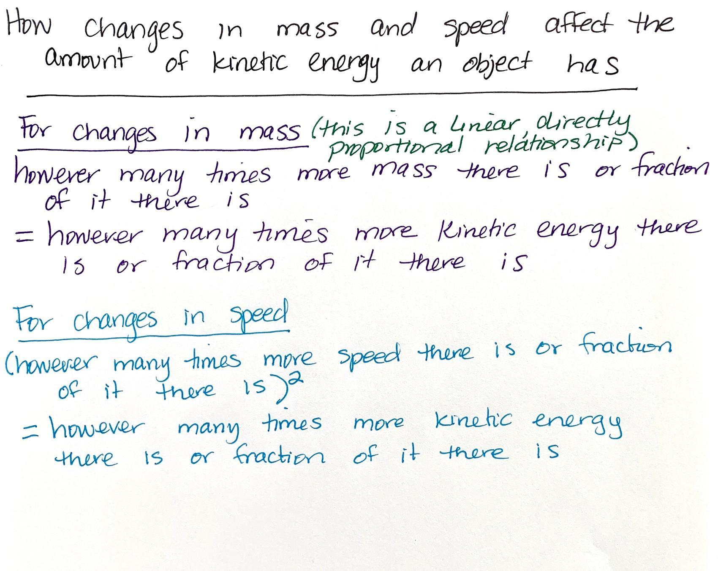  Say, We can represent that relationship in a general way. Add this to the chart paper:  For changes in speed (this is a nonlinear relationship)  (however many times more speed there is or fraction of it there is)²  = however many times more kinetic energy there is or fraction of it there is | ✱ SUPPORTING STUDENTS IN ENGAGING IN PLANNING AND CARRYING OUT INVESTIGATIONS  Students should readily recognize that the relationship between mass and kinetic energy is directly proportional, as such a relationship is one they have encountered in graphs many times in Common Core mathematics since 6th grade. Recognizing the relationship between speed and kinetic energy as nonlinear will also be straightforward. But describing the change in kinetic energy as being related to the square of the speed of an object will be challenging. To help students see this, you may find it useful to talk about the scale factors related to the changes.  One useful way of talking about scale factors is the number that describes how many times larger a new number is compared to an old number. Another way to think about scale factors is as a ratio of a new value to an old value.  Students will have encountered working with squared relationships in 6th grade, in finding the surface area of a cube with sides of length s, and in 8th grade they will be working with squaring the side lengths of a right triangle in their work with the Pythagorean theorem. Coordinate with your math teachers to determine where you students will be at in their familiarity with thinking about symbolic relationships like this.
  Suggested prompt | Sample student response
  Let’s start with changes in the mass. What patterns do you notice in your graphs and tables? | When the mass goes up, the kinetic energy goes up the same amount.  The ratio of kinetic energy to mass is constant.
  If we think back to Lesson 2 and work you have done in math class, how could we describe this relationship between mass and kinetic energy. | It is linear.
  A linear relationship is one way to describe this. We also can say it is “directly proportional” so that when one thing goes up, the other goes up the same.
  Let’s see what this means: How much would the kinetic energy of a moving object increase if it had three times as much mass but the same speed? | Three times as much kinetic energy.
  How about four times as much mass but the same speed? | Four times as much kinetic energy.
  So are you saying that however many times more the mass is, that tells you how many more times kinetic energy the object has? | Yes.
  Suggested prompt | Sample student response
  What if we scale the mass down so that it has one-third as much mass. How much should the kinetic energy of the object change? | It should be one-third of what it was.
  Suggested prompts | Sample student responses | Follow-up questions
  What about patterns about speed? What patterns do you notice in your graphs and tables? | The more you increase the speed of an object, the more the kinetic energy of it goes up. | How does the graph help you see that?  Can you show us what you mean?
  How much would the kinetic energy of a moving object increase if it had five times as much speed but the same mass? | Twenty-five times as much kinetic energy. | How did you figure that out?
  Suggested prompt | Sample student response
  How about four times as much speed but the same mass? | Sixteen times as much kinetic energy.
  So are you saying that however many times more the speed is, you can just take that number and square it and it tells you how many more times kinetic energy the object has? | Yes.
  What if we scale the speed down so that it has one-third as much as before? How much should the kinetic energy of the object change? | It should be one-ninth of what it was.
  ADDITIONAL GUIDANCE | Extension opportunity: For students who find more-complex computational thinking highly engaging, you could give them an optional set of questions to consider to express their understanding of how combined effects of changing both the mass and the speed of an object would affect its kinetic energy. These possible questions include the following:  - How would the kinetic energy of an object change if it had three times as much mass and double the speed? (answer: It would have 12 times the kinetic energy as it did before.)  - How would the kinetic energy of an object change if it had half as much mass and half as much speed? (answer: It would have one-eighth as much kinetic energy as it did before.)  - How would the kinetic energy of an object change if it had ten times as much mass but moved 1/10th as fast? (answer: It would have 1/10th the kinetic energy as it did before.)  - How would the kinetic energy of an object change if it had sixteen times as much mass but 1/4th the speed. (answer: It would have the same amount of kinetic energy as it did before.)

10 · INDIVIDUAL EXPLANATIONS | 5 min
MATERIALS: science notebook, 2 copies of Graphing Kinetic Energy Relationships, optional: 1 copy each of Alternate: Graphing Mass vs. Kinetic Energy and Alternate: Graphing Speed vs. Kinetic Energy, Looking back: Explaining and predicting kinetic energy changes in the system
Celebrate that we have a way to quantify changes in kinetic energy. Say, We made some real progress in figuring out a mathematical model that predicts how changes in mass versus changes in speed affect the kinetic energy of a moving object. But how does this help us more fully explain our anchoring phenomenon? Early in our work we said there is energy being transferred in collisions and that there are forces at work too. Let’s try to unite those two perspectives more fully by thinking about all the places energy is getting transferred in our launcher system.

Have students connect what we have figured out back to our anchoring phenomenon. Show slide L. Distribute Looking back: Explaining and predicting kinetic energy changes in the system. Emphasize that this is a formative assessment that you want to collect along with the graphs at the end of the period and that it focuses on the work we have done in this lesson. Give students the remaining time to complete the questions on Looking back: Explaining and predicting kinetic energy changes in the system and have them turn this in along with their graphs at the end of the period. Students may use their science notebooks as reference for this task. If time is short, assign this as home learning to turn in at the start of the next lesson or move it to the start of that lesson as an entrance ticket.

ASSESSMENT OPPORTUNITY | Building towards: 7.B Construct an explanation based on quantitative relationships (scale) for whether decreasing the mass of a moving object or decreasing its speed would have a bigger effect on the peak forces produced in a collision between it and a stationary object and use these ideas to further explain why this would cause damage in some collisions but not others (effect).  What to look for/listen for: On Looking back: Explaining and predicting kinetic energy changes in the system, any answers for questions 1 and 2 are acceptable. Many students will say that all three investigations were useful for question 1 (understanding the relationship between kinetic energy and damage). Most students will say investigation 3 in particular was most useful for question 2 (understanding the relationship between changes in mass and speed of a moving object and the amount of kinetic energy it has). Look for the following answers for questions 3 through 5:  - Q3): Reducing the mass of an object in half should reduce the kinetic energy to be half of what it was.  - Q4): Reducing the speed of an object in half should reduce the kinetic energy to be one quarter of what it was.  - Q5): We can predict how much more or less kinetic energy an object has when its speed or mass increases or decreases. These changes in kinetic energy would affect the peak forces produced in a collision. And if those peak forces don’t exceed the elastic limit of the materials or objects that collide, then no damage will occur, but if they do exceed it then damage will occur.  What to do: If students incorrectly answer Q3 or Q4, have them refer to specific data they gathered from investigation 3 where the mass was halved and the speed was halved and have them calculate the related fraction of kinetic energy that resulted from this change, then have them use this calculation to support, refute, or revise their claim. If students don’t connect to ideas about peak forces or elastic limit in Q5, ask them, What ideas can you use about peak forces and the elastic limit of materials to develop a chain of cause and effect between how factors that affect kinetic energy like mass and speed are related to what is happening during the actual collision that helps explain why damage occurs or not?

11 · NAVIGATION | 5 min
MATERIALS: science notebook, 3 sticky notes (3” x 3”), marker, Interactions in the System poster from Lesson 2
Unite two additional ideas related to energy transfer. Say, You’ve just used the model we developed to explain how changes in the mass or the speed of an object would affect whether damage would result in a collision. This model uses kinetic energy of a moving object as an important way of predicting what will happen in a collision.  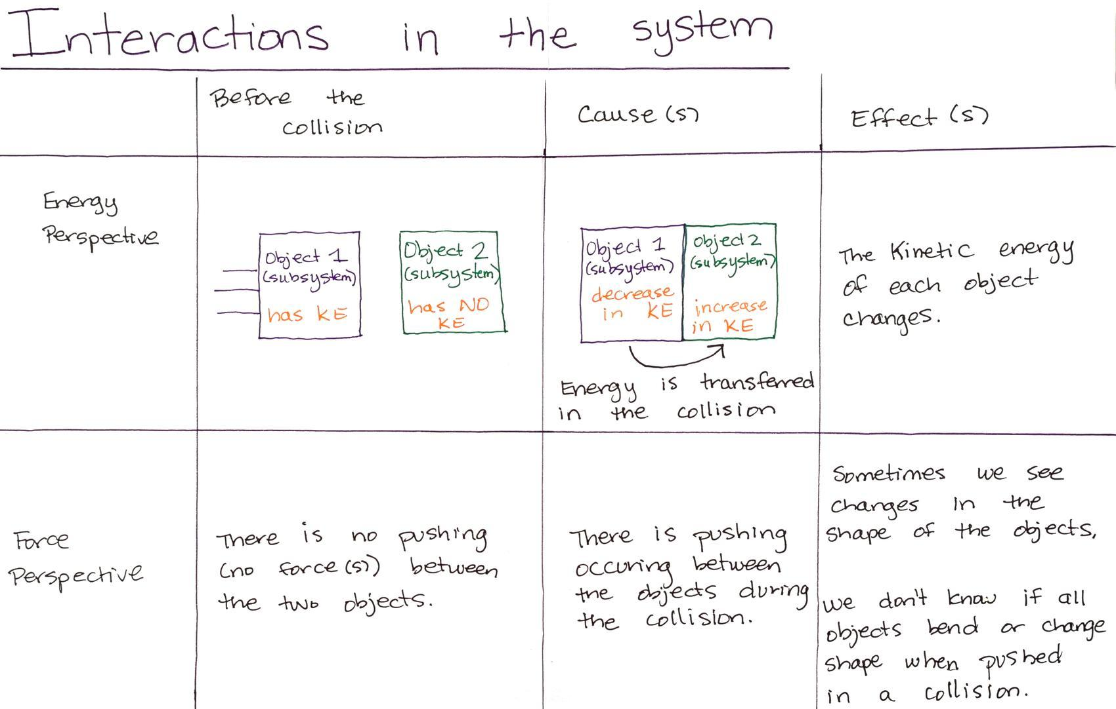  Refer to the Interactions in the System poster you made at the end of Lesson 2 that summarized an energy perspective and a force perspective in a collision. Point out that this poster reminds us of how we initially argued that energy is transferred in collisions and that there are forces involved.  Problematize where the energy is coming from and going to in the system. Say, But when we initially made this poster you provided a lot of examples of other systems where you tracked the energy flow across the system. You gave examples of phenomena that included things like cold liquid in a cup warming up or the formation of a hailstorm or the changes in the size of orangutan populations as a result of changes in the amount of accessible fruit trees in a forest ecosystem. In all these examples, we tried to track where the energy came from and where it went to in the system in order to better understand the phenomena.✱  Problematize where the energy comes from in the system and where it is going. Say, Thinking about where the energy is coming from and where it is going in a collision could help us understand and explain even more about collision-related phenomena. So let’s consider an energy perspective for the entire system we used in this lesson with the cart, spring scale launcher, track, cracker, and box.  Show slide M. Have students turn and talk to discuss the questions on the slide.  Save the last minute to have students make note of what new questions they have. If time permits you could have them write these new questions on sticky notes and add them to their science notebooks to share next time. Either way, suggest to the class that we will pick up our next lesson with this line of thinking by having students share some of the new questions that they are now considering about the entire system we used in the first two investigations in this lesson. | ✱ SUPPORTING STUDENTS IN DEVELOPING AND USING ENERGY AND MATTER  These are just a few examples of the kinds of phenomena you could reference from other OpenSciEd units students have completed. Instead of repeating the examples here verbatim, cite the actual examples and how students described them that they mentioned in Lesson 2.  This cross-unit connection is an important one to make now to help recall how common and therefore how generalizable and powerful the use of the crosscutting concept is across the prior system models that students have developed in OpenSciEd units: The transfer of energy can be tracked as energy flows through a designed or natural system.
  SUPPORTING STUDENTS IN MAKING CONNECTIONS IN MATH | Students calculate and use a type of ratio called a scale factor in this lesson. Students will have encountered this concept before in math class in one or both of these contexts:  - 7.G.A.1 Solve problems involving scale drawings of geometric figures, including computing actual lengths and areas from a scale drawing and reproducing a scale drawing at a different scale.  - 7.RP.A.2 Recognize and represent proportional relationships between quantities.  There are multiple connections between the work students will be doing in this lesson and the work they will be doing in math class this year (grade 8). These include the following:  - 8.F.B.5 Describe qualitatively the functional relationship between two quantities by analyzing a graph (e.g., where the function is increasing or decreasing, linear or nonlinear).  - 8.EE.A.1 Know and apply the properties of integer exponents to generate equivalent numerical expressions.

